EFRAG
35 Square de Meeus
1000 Brussels
Belgium

9 September 2011

Dear Sirs

Considering the effects of accounting standards

ACCA (Association of Chartered Certified Accountants) is pleased to have this opportunity to comment on the above Discussion Paper (DP) which was considered by ACCA’s Financial Reporting Committee. I am writing to give you their views.

Overall comments

We strongly agree with an overall contention of the DP as we see it, namely that decisions throughout the process of setting accounting standards by the IASB should be based on evidence, to justify in particular
- Agenda decisions as to whether existing standards should be amended or new ones developed
- The solution proposed by an exposure draft
- That an amendment or new standard in reality achieved what was intended

This DP generalises too much the different sorts of evidential or effects studies. The three key points in the standard setting cycle noted above may need rather different sorts of studies whereas this DP seems to treat them as largely the same. See our answer to Q3&4 and to Q15 to 17 in particular.

The detailed process set out in this paper risks being bureaucratic, potentially box-ticking and over-elaborate and might trap the IASB’s activities in an overly lengthy due process. See especially our answer to Q16&17 below.

More emphasis in the DP should have been placed on transparency and publication of the effects studies or evidence, including for instance the field tests that IASB refer to from time to time.

In paragraph C6 of their recent strategy review the IFRS Foundation Trustees referred to developing a research capacity for IASB. Helping to gather the evidence for effects studies could be the major role of such a research capacity. ACCA in conjunction with IAAER (International Association for Accounting Education and Research) held a recent roundtable to investigate further the issues involved in such a research capacity. We intend to provide EFRAG and the ASB with a report on this in due course.

Responses to the DP’s specific questions

Q1. Definition of effects analysis

Agreed, though we consider “evidence” is a better term than “effects” but in substance is similar.
.

Q2. Integration of effects studies into standard setting

Agreed. We have proposed to the IASB that they should make evidence-based decisions on the agenda and on the development of the standards to ensure they are practical and achieve their aims.

Q3. Who should do them?
Q4. When should they be done?

The effects studies fall into 3 different types in our view

- Evidence of the problem to be addressed (to justify the agenda decision and be the introduction to a discussion paper)
- Assessment of the implications of the solution proposed (in support of the proposals put forward in the ED and updated for the standard)
- Assessment of how well the solution has worked – a post implementation review (PIR)

We would expect that an IASB discussion paper for example would include the justification for the project (Type A), but we would not expect it to have an effects study (Type B) for each possible option that might be included. This seems too impractical and time consuming both for the standard setters and for constituents – they might spend time assessing unlikely possibilities and permutations that might interact.

This DP generally seems too much inclined to lump together these different types of effects studies than to distinguish their different features. It seems to concentrate on the mechanics and nature of Type B and then apply them to Types A and C as well.

There is a good case in governance terms for the Trustees to commission from independent sources and oversee studies of Type A and Type C, leaving the IASB to carry out the Type B.

The area in recent years where the oversight of the Trustees over the IASB has been most inadequate has been in allowing the agenda of projects at IASB to expand unrealistically, be too driven by convergence with US GAAP and to include issues where there may be insufficiently significant problems in practice to justify changing the standards. A more direct involvement of the Trustees via Type A studies may help to avoid this in future. We do not consider that the involvement of others in the agenda setting compromises the independence of IASB’s judgment in the development of solutions to the problems posed.

Type C studies or PIR are potentially as much measures of the effectiveness of the IASB’s work as the impact of the individual standard. So arguably at least one sort of these should be commissioned and supervised by the Trustees as tangible evidence of their oversight of the IASB (see our answer to Q17 below).

As noted above the research capacity could be instrumental in helping the Trustees perform these roles.

Q5. Proportionate studies

Agreed.

Q6. Definition of effects
Q7. Effects rather than cost/benefits

While we agree that there are limitations on the ability of cost benefit analysis (CBA) to deal with all cases, we think the emphasis and aim should be to do CBA whenever possible, even where the results may be no more precise than to show that one solution may be more costly or beneficial than another. Greater use of CBA is likely to lead to methodological improvements.

The development of standards also requires questions and judgments as to the overall value of the standard.

Q8. Include both micro and macro effects

Agreed. The IASB’s justification of the development of global standards has ultimately been on macro-economic grounds – more comparable and higher quality financial information helps make capital markets more efficient thus reducing the average cost of capital. The development of individual standards needs to be supported by net macro-economic benefits in a similar way.

Q9. Limitation of effects

EFRAG and ASB should reconsider their explanations here, as this in principle seems difficult to fit with including macro-economic effects as in Q8 above. However we agree that the IASB should concentrate on capital market and business effects and not for example on tax implications or the implications for prudential capital requirements. IASB must assume that other regulators may have to react to changes in accounting where they make use of the financial statements.

Q10. Public interest as the objective

Agreed.

Q11. More detailed issues

We do not think these need to be included in any due process formulation.

Q12. Measuring impacts

Agreed.

Q13 and Q14. Principles underlying effects analysis

While these do not contain anything wrong or misleading, we do not consider they add anything substantial to this DP or would add anything substantial to a new due process document.

Q15. Steps in validating outcomes

Agree that all the steps in 5.2 should apply at the agenda setting stage (Type A study), though be carried through to Type B as well.

Q16 and 17. Steps in assessing effects

The process EFRAG/ASB seem to be setting out is overly demanding and complex that could be simplified along the lines suggested below.

In 5.3 a) while we agree these should be done, these do not constitute effects studies as we would understand them. We would expect the IASB to consider different possible solutions and compare them against the conceptual framework and treatments of comparable issues. This and practical experience is likely to produce the best answers. The role of effects studies of Type B is to confirm these decisions and this is what seems to be set out in the rest of paragraph 5.3. However the steps seem over-elaborated. What may be largely needed for Type B studies are the sorts of issues referred to under Q6 to 8 above.

At the ED stage the IASB should only be obliged to complete the sort steps covered by 5.3 b) to f) for their proposed option and not for all the options that they also considered. The main comparison would be their proposals against existing practice which ultimately should justify the decision they are exposing for comment.

Paragraph 5.4 is not needed as it seems to largely duplicate what is in 5.3.

What the DP is missing is a consideration of how a PIR might be conducted. There seem to be two main objectives of these
- To gather evidence of how well the standard has been applied by preparers, what application issues arose which would lead to further guidance, interpretations and amendments to the new standard as appropriate
- To consider whether the standard achieved its objectives and what other unforeseen consequences it had

These seem to point to very different studies which are seeking different sorts of effects, might need to be done by different bodies (see our answer to Q3 and Q4 above) and on different timescales. The first sort of PIR might be needed soon after the standard is implemented, say in two years. That period might be too early to judge the second group of effects that should nonetheless also be the subject of PIR.

Q18. Role of national standard setters (NSS)

We have noted above in answer to Q3 and 4 above how the responsibility for The effects studies of Type A, B and C should be allocated within the IFRS Foundation. It is up to them to organise this most efficiently and effectively involving others, such as NSS, or not as seems appropriate.

Q19. Next steps

At a minimum IASB should consider the proposals in this paper and issue a consultation on its due process in this regard.

If there are any matters arising from the above that require further clarification, please contact me.

Yours sincerely

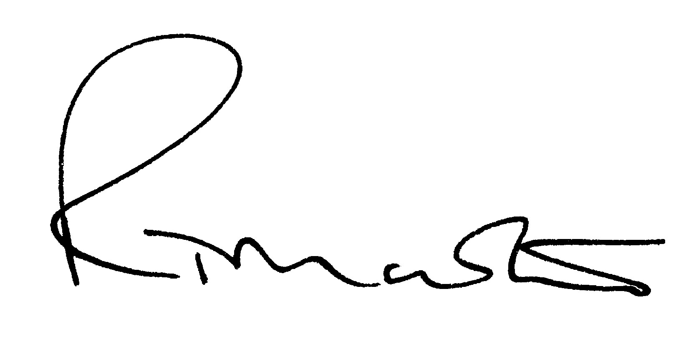

Richard Martin
Head of Financial Reporting

